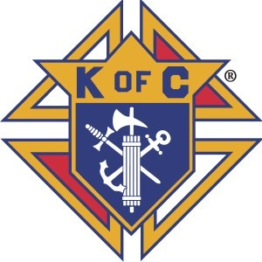
The Knights of Columbus
VOLUNTEER RELEASE FORM

As a condition for volunteer consideration with the above organization, I understand a background investigation may be performed.

I authorize the Knights of Columbus, Accutak Investigative Services and any other agent to verify
my background prior to, or at anytime during my service, which may include: criminal records, driving records, or any other required information.

I release The Knights of Columbus, Accutrak, and any other agent from liability or damages whatsoever for the obtaining of any background information prior to, or at anytime during my service. This is not part of any employment application and is used for verification only.

PLEASE PRINT
Full Name: _ Social Security # Does Not Apply

Date of Birth: _ Drivers License # :Does Not Apply _ ST. XXX
Current Address: _ _ City, State, Zip: _
Applicant Signature: _ _
Date:

All parties agree to keep all applicant background information in strict confidence, will use the information for lawful purposes, and will adherer to the Fair Credit Reporting Act and all other applicable laws.

Fax, email, or mail this completed form to:

ACCUTRAK
Fax (972) 390-2195
email: accutrak2@aol.com

Council Name and # Council SEP Representative Email or Snail Mail Address Bill To
Accutrak P.O. Box 260 Allen, TX 75013 Phone (972) 390– 2109 Fax (972) 390-2195

