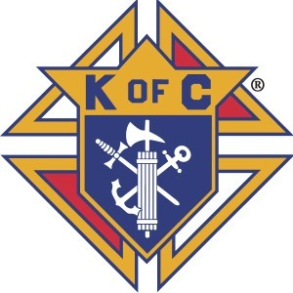
ACKNOWLEDGEMENT

This Safe Environment Program Booklet has been prepared as a guide to assist you when working with minors and vulnerable adults. The information contained in this manual establishes rules and guidelines. The Knights of Columbus re- serves the right to make changes in the content of this booklet and to implement those changes with or without notice

I have received a copy of the Safe Environment Program Booklet for the Knights of Columbus. I understand it is my responsibility to be- come familiar with and adhere to the policies and procedures contained therein. I understand that this booklet is the property of the Knights of Columbus Dallas Diocese.

Print Name

Signature

Date

