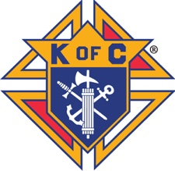

American
Wheelchair Mission

Knights of Columbus Wheelchair Program - Dallas Diocese

Knights have helped us sponsor the delivery of tens of thousands of wheelchairs worldwide! A $150 will deliver a brand-new wheelchair to a child, teen, or adult in need of Hope, Mobility, Freedom, and Independence.

○ $150 ○ $300 ○ $500 ○ $1,000 ○ Other $_________________ (Any amount is greatly needed and appreciated)

Donor/Contact Name_____________________________________________________________Council: _________

Address ___________________________________________________________________________________________

City ______________________________________ State______________ Country_______ Zip__________________

Telephone _____________________________E-mail _____________________________________________________

With a donation of $500 you will receive a blessed Lithograph of Our Lady of Guadalupe
○ A Lithograph was presented at the time of donation. ○ A Lithograph needs to be shipped to donor.

With a donation of $150 you will receive a beautiful certificate of thanks with a photo of a wheelchair recipient.

CERTIFICATE WILL READ: American Wheelchair Mission wishes to thank:
○ Donor (above) ○ Council Above

○ Other ______________________________________________________________

For the Gift made:
○ No designation ○ In the Name of ○ In Honor of ○ In Memory of

____________________________________________________________________
○ No Certificate Please

○ Check enclosed ( ○ I am interested in attending a wheelchair distribution )
Credit Card ○Visa ○MasterCard ○American Express ○ Discover

Name as it appears on card _________________________________

Card Number ___________________________________________________ Exp. Date ______/_______
Mo Yr
Signature ___________________________________________________

▌ PLEASE MAKE CHECK PAYABLE TO: AMERICAN WHEELCHAIR MISSION ▌
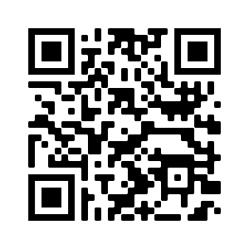
Mail Contribution(s) To: American Wheelchair Mission
Attn: Dan Moberg
560 W. Main Street, #C804
Alhambra, CA 91801-3376

To donate online, scan the QR Code with a smart phone or visit
WWW.AMWHEELCHAIR.ORG/DONATE

In the Campaign Field select “Knights of Columbus”
and in the Organization Field enter your Council Number.

For more information please contact: E-mail dmoberg@amwheelchair.org - Phone (208) 457-0745

American Wheelchair Mission is a 501(c)(3) tax free organization - Tax ID# 26-4571639

