Congratulations and Best Wishes on a successful 119th Texas State Convention in Dallas, Texas
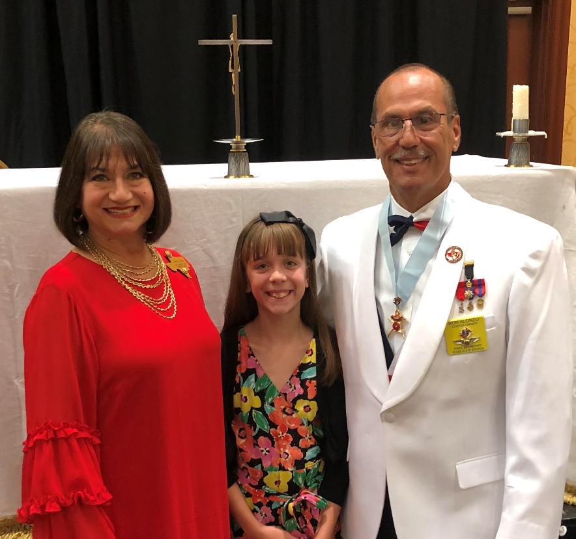

Congratulations to all the Texas Knights! Your hard work and perseverance have paid off. Your leadership once again has Texas in the Supreme Knight’s Circle of Honor. We look forward to being with you at the Dallas Convention to recognize your achievements and renew our fraternal bonds.
God Bless Texas! Enjoy the Convention!
State Secretary
Ron and Margo Alonzo
& Mackenzie

