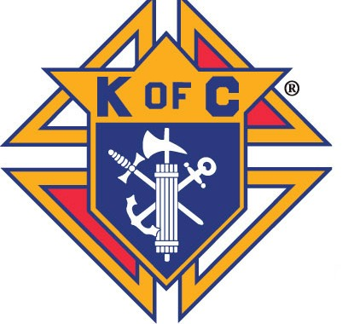 Knights of Columbus Wheelchair Program 2025-2026 
The Knights of Columbus work in partnership with the American Wheelchair Mission to provide wheelchairs to an estimated over 100 million people worldwide that need a wheelchair, but cannot afford one.
Some highlights of the Wheelchair Program:
- Wheelchairs allow children to go to school for the first time, adults to go to work, and the elderly to get out of bed.
- Wheelchairs are a life changing gift of mobility that answer prayers and deliver hope, dignity, freedom and independence.
- It is estimated that each wheelchair delivered changes and improves an average of 10 lives.
- Retailing at $500, each wheelchair is delivered at an average cost of $150.
- 100% of a donation goes towards the purchase and delivery of a wheelchair, as the Knights of Columbus cover overhead costs.
- A $150 donation allows you to request a personalized Certificate of Thanks, which includes a photo of a wheelchair recipient.
- A $500 donation allows you to request a framed 34” x 23” Our Lady of Guadalupe lithograph, blessed at her Basilica in Mexico City.
- A Council donation of at least $1,500 for 10 wheelchairs, counts 2 program credits towards earning the Columbian Award.
- Wheelchair Sundays are the most effective way to raise funds for this program and a great way to recruit new members.

Thank you so much and God bless you to the 245 Councils and 5 Assemblies that raised an absolutely incredible jurisdiction record of $1,561,788 for 10,412 wheelchairs in fraternal year 2024-2025. Through you, so many prayers were answered, and you impacted the lives of 104,120 people! California, our closest competition, raised $334,196 for 2,228 wheelchairs.
The goal for District Deputies, in fraternal year 2025-2026, is to have all their Councils participate in the Wheelchair Program by donating at least $150 for one wheelchair and have at least one of their Councils hold a Wheelchair Sunday. The State goal is to set a new jurisdiction record by exceeding the total from last fraternal year. There were 585 Texas Councils that did not donate last fraternal year.
To donate online, please visit amwheelchair.org/donate and select “Knights of Columbus” in the Campaign field and enter your Council Number in the Organization/Council field. Please contact us with questions, wheelchair needs or Wheelchair Sunday help.
Bill Weber, Texas Wheelchair Chairman, 214-405-8023, yankeesweb@tx.rr.com, Plano Brian Nelson, Assistant Wheelchair Chairman, 210-275-7921, abn091951@gmail.com, San Antonio

Donations by Diocese
Diocese | FY 2023-2024  Final | FY 2024-2025  Final
Amarillo | $1,100 | $2,050
Austin | $45,626 | $95,422
Beaumont | $15,540 | $18,645
Brownsville | $2,550 | $1,650
Corpus Christi | $11,143 | $10,802
Dallas | $661,690 | $799,163
El Paso | $1,900 | $78,580
Fort Worth | $59,524 | $89,205
Gal/Hou | $136,943 | $118,152
Laredo | $19,030 | $40,564
Lubbock | $4,107 | $6,123
San Angelo | $22,604 | $17,425
San Antonio | $181,530 | $244,473
Tyler | $9,525 | $8,897
Victoria | $26,298 | $30,635
Total | $1,239,052 | $1,561,788
 | Top 15 Texas Councils in FY 2024-2025
Rank | Council | Parish/Council | City |  | Amount
1. | 11716 | Prince of Peace | Plano |  | $168,282
2. | 5052 | Mary Immaculate | Farmers Branch |  | $150,026
3. | 638 | St. Joseph | El Paso |  | $78,280
4. | 6065 | St. Mark the Evangelist | Plano |  | $72,207
5. | 7613 | St. Mark the Evangelist | San Antonio |  | $42,961
6. | 14512 | St. Edward | Spring |  | $40,859
7. | 8417 | St. Joseph | Waxahachie |  | $40,754
8. | 11293 | St. Jude | Allen |  | $40,324
9. | 10131 | St. Ignatius Martyr | Austin |  | $39,933
10. | 13704 | Padre Pio | San Antonio |  | $34,305
11. | 9967 | Holy Trinity | San Antonio |  | $32,377
12. | 6878 | St. Mary Magdalene | Humble |  | $29,388
13. | 13044 | Our Lady of Angels | Allen |  | $28,015
14. | 4183 | Holy Family, Our Lady of Perpetual Help and Saints Peter and Paul | New Braunfels |  | $27,712
15. | 12964 | Corpus Christi | Ferris |  | $27,465

